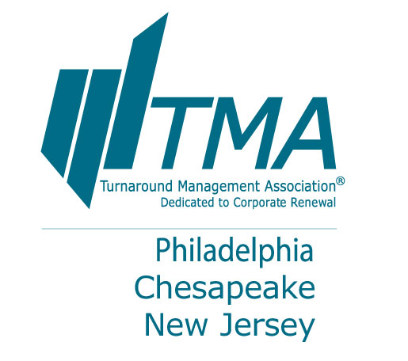

**Directions to GOLF**

**Atlantic City Country Club**

One Leo Fraser Drive

Northfield, NJ 08225

609-236-4411

[www.accountryclub.com](http://www.accountryclub.com)

From Atlantic City:

Take the AC Expressway West to Exit 4, Pleasantville exit (first exit past tollbooth). Turn left at end of ramp onto Franklin Avenue. Turn right at next light onto Route 322, Black Horse Pike. Turn left at next light onto Main Street (Dunkin Donuts on corner). Main Street becomes Shore Road. The club entrance is on the left approx. 3 blocks past the County Stillwater facilities building.



**Directions to SKEET SHOOTING**

**Red Wing Sports Clays**

317 Sooys Landing Road

Port Republic, NJ 08241

609-381-1200

[www.redwinglakes.com](http://www.redwinglakes.com)

1. From Caesars, heading northeast on Pacific Ave. toward S. Arkansas Ave
2. Turn left onto S. Dr. Martin Luther King Blvd. (approx 1 mile; S. Dr. Martin Luther King Blvd. becomes Huron Ave)
3. Turn left onto Absecon Blvd./US-30 W (approx 6 miles)
4. Turn right onto N. New Rd/US-9 N
5. Turn left onto Pitney Road/County Highway-634 (follow Pitney Rd, approx 6 miles)
6. Turn slight left onto Old New York Rd/County Hwy-610
7. Take 2nd left onto Clarks Landing Road/County Hwy 624 (approx 1 mile)
8. Turn right onto Sooys Landing Road



**RESORTS CASINO HOTEL | 1133 BOARDWALK | Atlantic City | New Jersey 08401 | 800-334-6378**

[**www.resortsac.com**](http://www.resortsac.com)